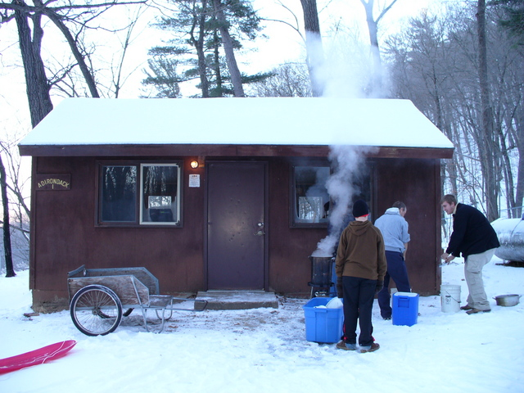
Activity: Winter Cabin Camping
Location: Fred C. Andersen Scout Camp
Dates: January 11-13, 2013
Departure: 5:30 p.m. Friday, CVBC
Est. Return: 12:00 noon Sunday, CVBC
COST: $20.00 ($9 for four meals; $11 for cabins)
Emergency contact: Art Marty, (Camp Ranger), 715-549-6641
or Tom Arneberg's cell phone: 715-404-0582

Details: We're heading back to "Fred C."! Once again we will be staying in the Adirondacks. They're a little more expensive, but each patrol gets their own small one-room cabin with eight bunks! (We reserved FOUR cabins this year...but we can get one or two more if needed.) Each cabin also has a gas heater and stovetop. The Fred C. Andersen Scout Reserve is nestled in the scenic bluffs of the St. Croix River near Stillwater, about 90 minutes west of Chippewa Falls. We will NOT be able to park right next to the cabin, but the hike to the Adirondacks is not as far as it is to other cabins. (Wheeled carts and sleds will be available.) There will be plenty of time for hiking, fire-building, cave exploring, sledding, advancements, Boards of Review, etc. The Patrol Leader Council will be planning some time of troop activity for Saturday morning and/or afternoon. Retain the above information and return the form below with any money by 7:00 p.m. Monday, January 7, 2013.

- - - - - - - - - - - - - - - - - (cut here; return bottom portion) - - - - - - - - - - - - - - - - - - - - - -

Winter Cabin Camping at Fred C. Andersen
Dates: January 11-13, 2013
Fees: $______ from boy's account + $______ enclosed check = $20.00
(make checks payable to "Troop72.com")

In consideration of the benefits to be derived, and in view of the fact that the Boy Scouts of America is an educational institution, membership in which is voluntary, and having full confidence that every precaution will be taken to ensure the safety and well-being of my Scout son/ward, namely:

First_________________________________________ MI____________ Last_________________________________________
on the activity above, I agree to his participation and waive all claims against the leaders of this trip, officers, agents and representatives of the Boy Scouts of America, and the sponsoring organization, Chippewa Valley Bible Church. In the event of an emergency, the troop leader of the activity named above has my permission to obtain medical treatment for this Scout at the nearest hospital or doctor, at my expense, if our own doctor is not readily available, and as restricted on the medical form on file with the Troop.
[ ] Yes, I will attend this activity with my son(s)
[ ] Yes, I can drive the troop trailer to/from the campsite

Signature of parent or guardian:____________________________________________ Date:_____________________

EMERGENCY INFORMATION ON FILE?
[ ] Yes, I have an updated medical form on file with the troop.
[ ] No, I still have to fill out that medical form and get it to the troop.
[ ] The following is new information since the medical form was filed:

Questions? Call Tom Arneberg (715-726-1728), or see the www.troop72.com web page.

